Guide to logging into REDCap and creating your first record
- Navigate to the REDCap login page using the following link: https://capture.phfscience.nz//
  - We recommend using Chrome or Firefox, Internet explorer will work but is a slower experience.
- You will be greeted by the REDCap login page. Here you should enter your username (this typically consists of the first letter of your first name and your last name) and your password.
  - You will receive a link in your email address with a link to setup your password and secret question when the REDCap administrator creates your account for the first time. If you do not see the email to setup your password, please check your junk email box. When you setup your password you will be automatically logged in for the first time, so skip to the next step.
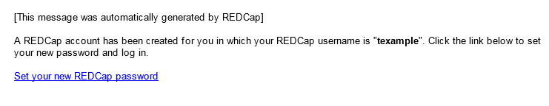
  - If you have forgotten your password the blue link “Forgot your password” on the login page can be used to change it. You will need the answer to your secret question. A link will be emailed to you allowing you to reset your password.
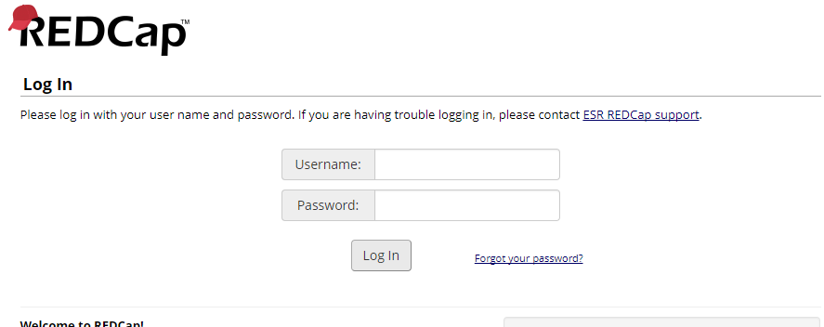
- When logged in you can view the projects you have been allowed access to by clicking on “My Projects”
  - If you don’t see a project you believe you should have access to, contact CDRSupport@phfscience.nz with your username and they can add you to the project. For Syphilis surveillance you will be part of a Diagnostic Access Group (DAG) which limits your and others access to records to those within your DAG (there will be separate DAGs for each clinic/region).
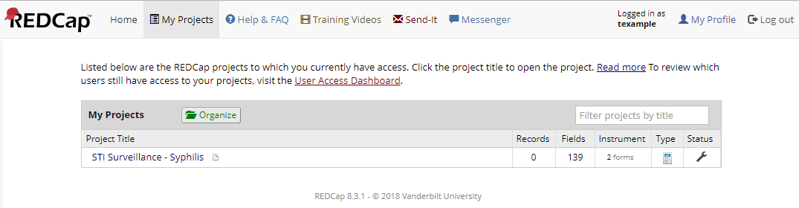
- Click on the project of interest to access it. You will be greeted with the project home page. From here (if you have the permissions for it) you can create a new ‘record’ or view existing ones.
  - Note records you create can only be seen by those within your Diagnostic access group (DAG), also you can only see records that belong to your DAG.
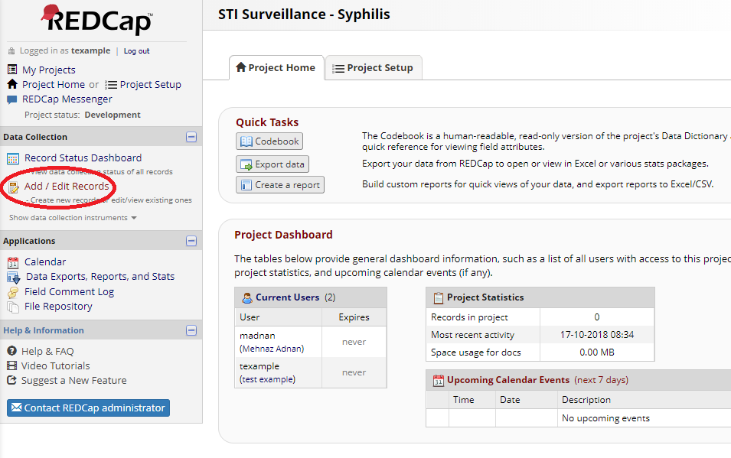
- You can create a new record or view an existing one, individual fields can also be searched using the “Data search” window.
  - To create a new record select “Add new record”.
  - To open an existing record, start typing into the “search query” if you know the case-code, NHI or other unique data.
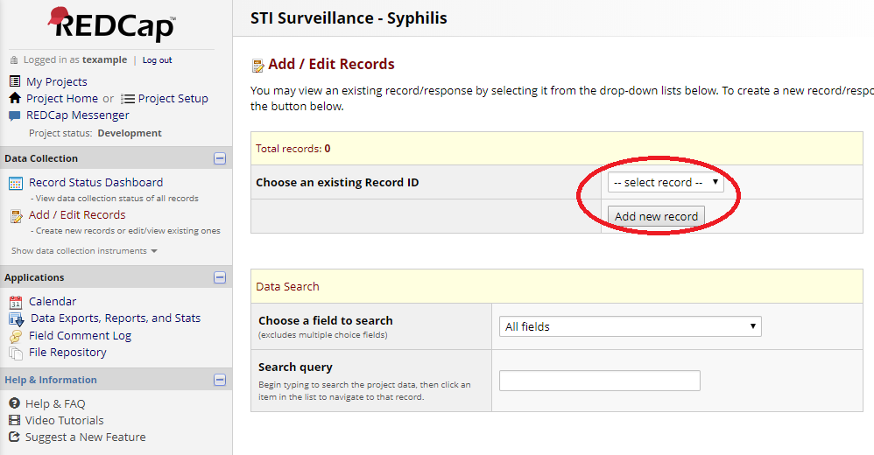
- When you create a new record, or wish to edit an existing one, you need to select the ‘instrument’ you wish to enter data into by clicking the status icon. This will open the survey form.
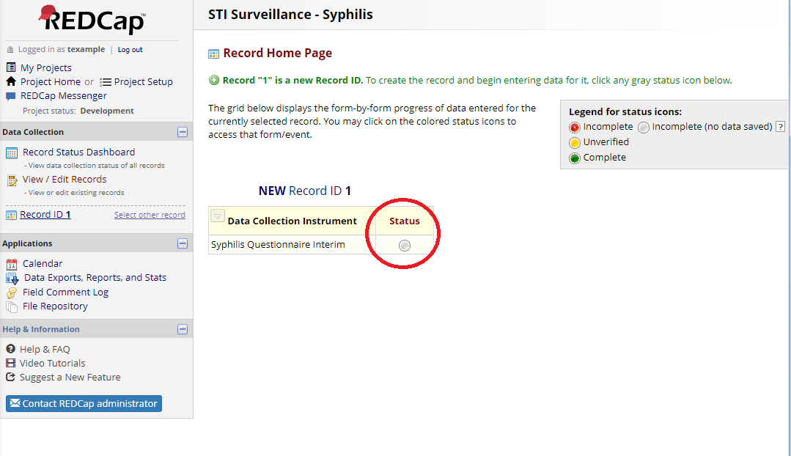
- As you fill out the questionnaire there will be questions that are hidden or revealed based on answers to other questions (this is known in REDCap as ‘branching logic’). When you want to save your progress and leave the record click one of the ‘Save and Exit Form’ buttons, if you wish to stay select the second button “Save and Stay”.
  - If you don’t save the form none of the changes you’ve made will be retained. As your session will logout after 30 minutes of inactivity you should save any changes as you go.
  - Remember you can return to a record you have saved and edit at a future time.
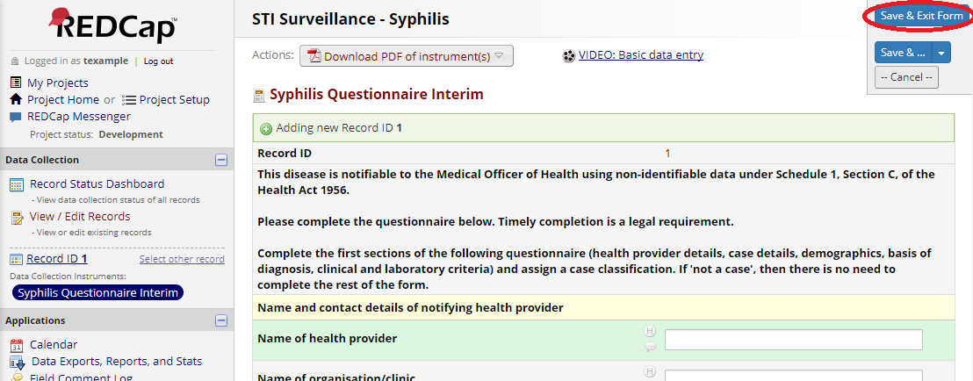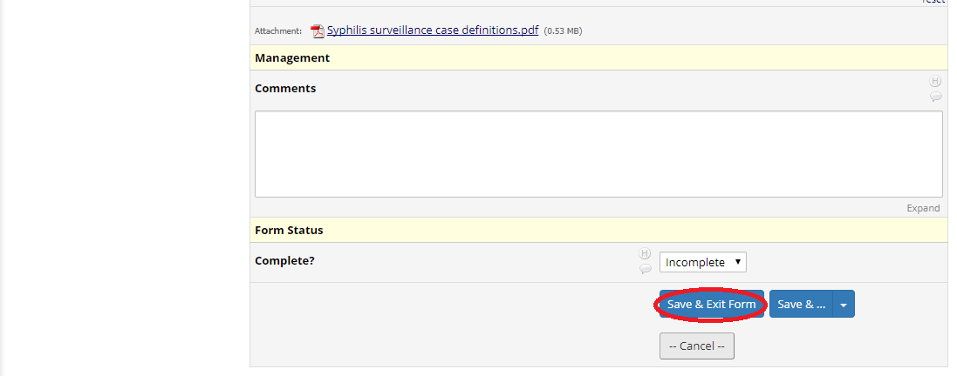
- You’re done! When finished please don’t forget to sign out using the “Log out” link in the top left of the project page or the top right of the main REDCap page.

