Instructions for gonorrhoea notifications

Health Practitioners in New Zealand are required to report cases gonorrhoea to the Institute for Public Health and Forensic Science (PHF Science) via a web-based case notification (we use a secure data capturing software called REDCap). PHF Science has designed an online notification form using a REDCap ‘questionnaire’.

Before you notify a case:
Please note that the online form generates a new record as soon as you click Begin survey
Please ensure that you have as much information on the case as possible before starting the notification. We ask for NHI (used to match lab results but anonymised when analysed), demographic details, testing information, and risk factors including sexual behaviour.

To notify a gonorrhoea case, copy and paste the following link into a new browser tab:
https://capture.phfscience.nz/gono

What should I see after copy-pasting the link into my browser?
- You should be directed to a reCAPTCHA “I am not a robot” verification page.
  - Once you click “Begin Survey”, you will be prompted to enter your practitioner registration number and an email address.
- Once you click “Begin Survey”, you will be prompted to enter your practitioner registration number and an email address.
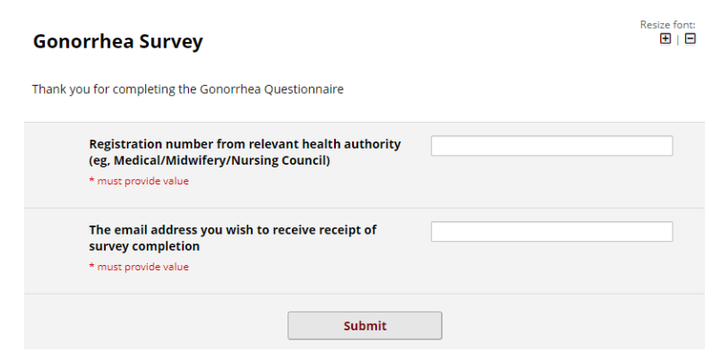
- Click Submit to proceed to and complete a new case notification.

What if copy-pasting https://capture.phfscience.nz/gono is not working for me?
Please email CDRsupport@phfscience.nz (you can phone 0800 377 237, but we will need to email you anyway so emailing first is best).

